OSCE 2nd Jun 2021

Case 1

32/M, good past health
c/o fever with cough for 3 days, vague chest discomfort.
He had bodycheck 1 year ago and the ECG was told normal.
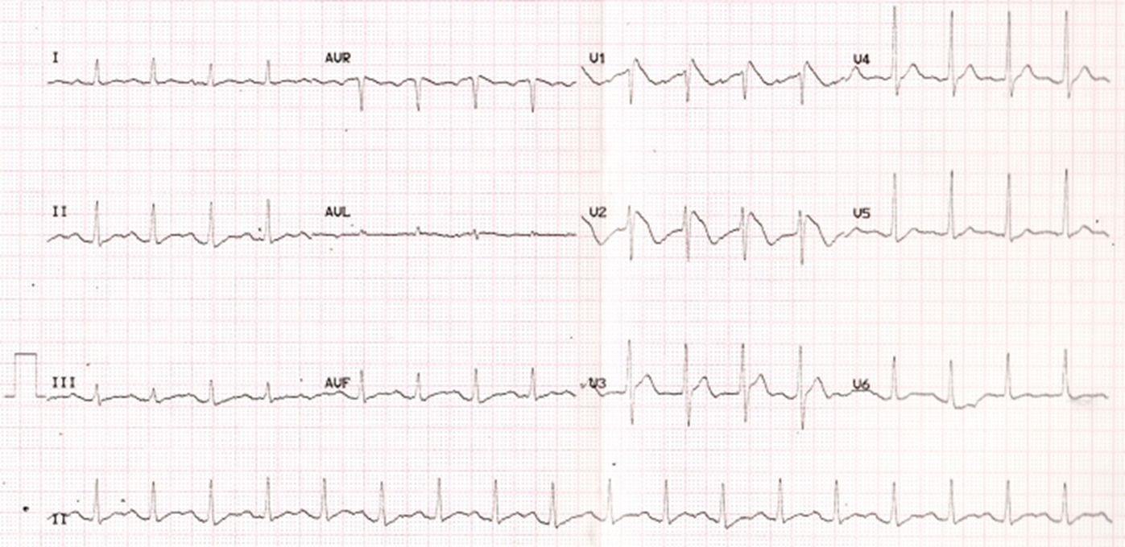

1) Please describe the ECG finding

2)What is the name of this ECG sign?

3)Apart from fever, name three other factors that can lead to this ECG change?

4)What is the definitive treatment for this condition?

5)Apart from the ECG sign, name any three factors that need to be present before you decide for the treatment in 4)?

Case 2
42/M
c/o dyspnea after waking up from sleep. Went out for dinner with friend last night
and drank 1 bottle of whisky.

BP: 135/80, p: 85/min
SpO2: 96% in RA, Temp: 36.5
ECG: NSR, 90/min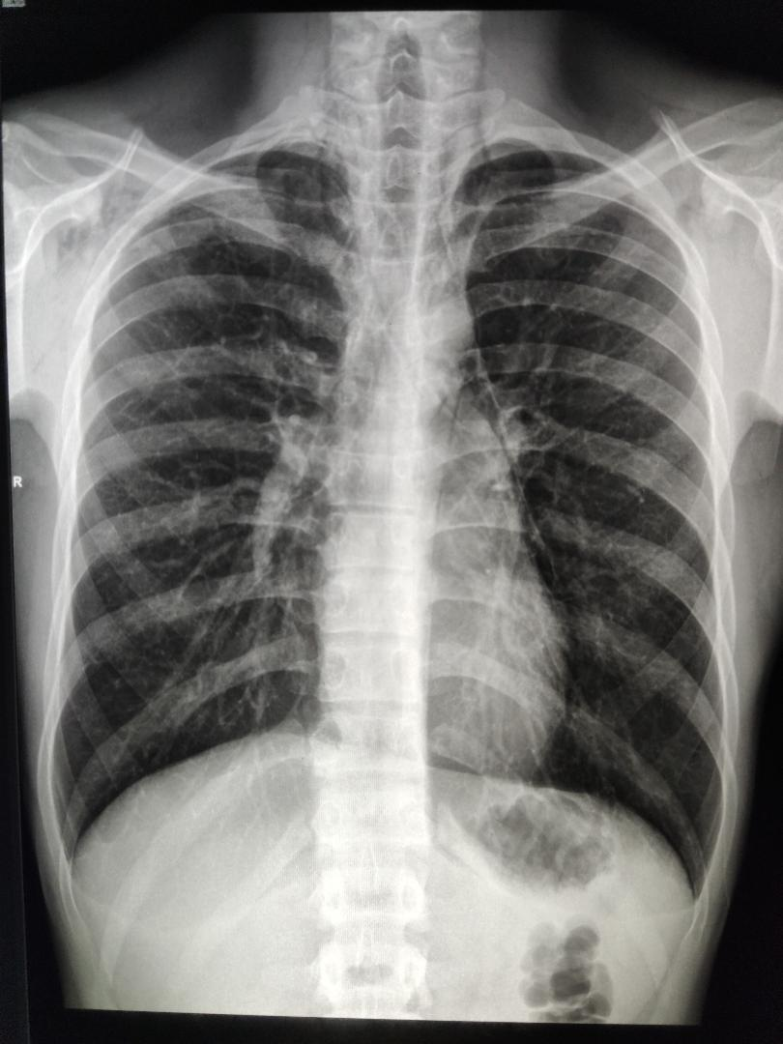

1) Describe the CXR findings:

2)How would you classify the condition in 1)? and give one predisposing factor for each type

The patient was admitted for further management. On arrival at ward, he became increasingly distressed
BP: 100/70, P: 100/min, SpO2: 94%, temp: 37.5

3)What are the possible complications? Name 2

4)Name two further investigations you would like to confirm your answer to 3)

Case 3

20 year old man drunk last night and wake up from sleep.
c/o right shoulder pain, excruciating pain when moving his right shoulder

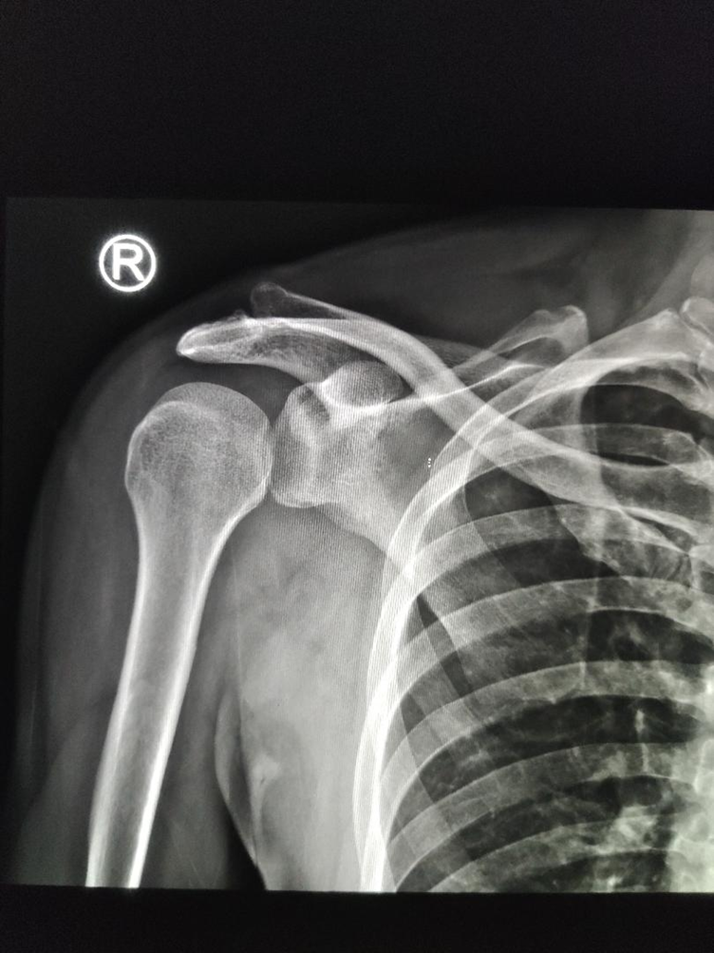

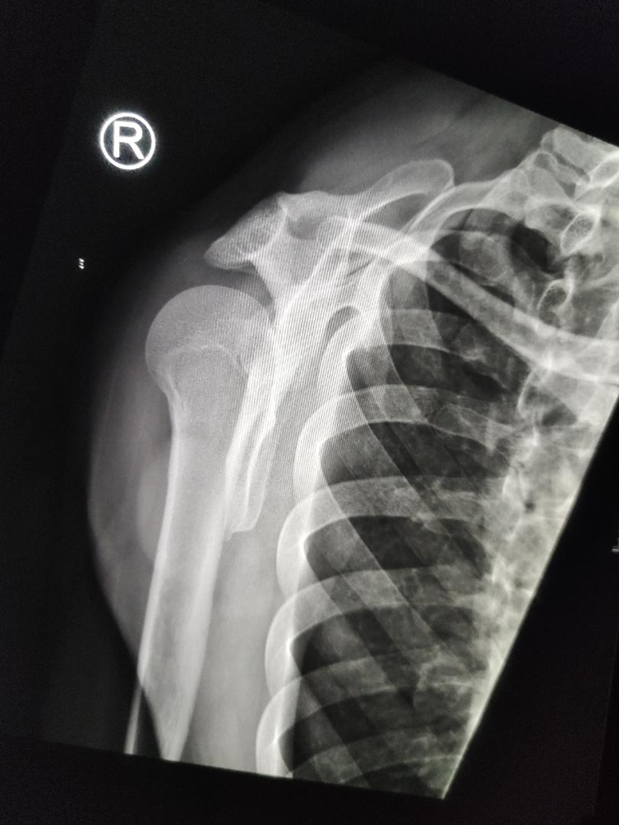

1)What is the diagnosis?

2)Name four signs on the x-ray to support your diagnosis

3)Your senior does not concur with your findings, name two ways you can confirm your diagnosis at A&E?

4)What are the complications associated with this condition? Name three

Case 4

60/F, head injury at 8am
S/F with head contusion, c/o persistent headache
GCS 15/15

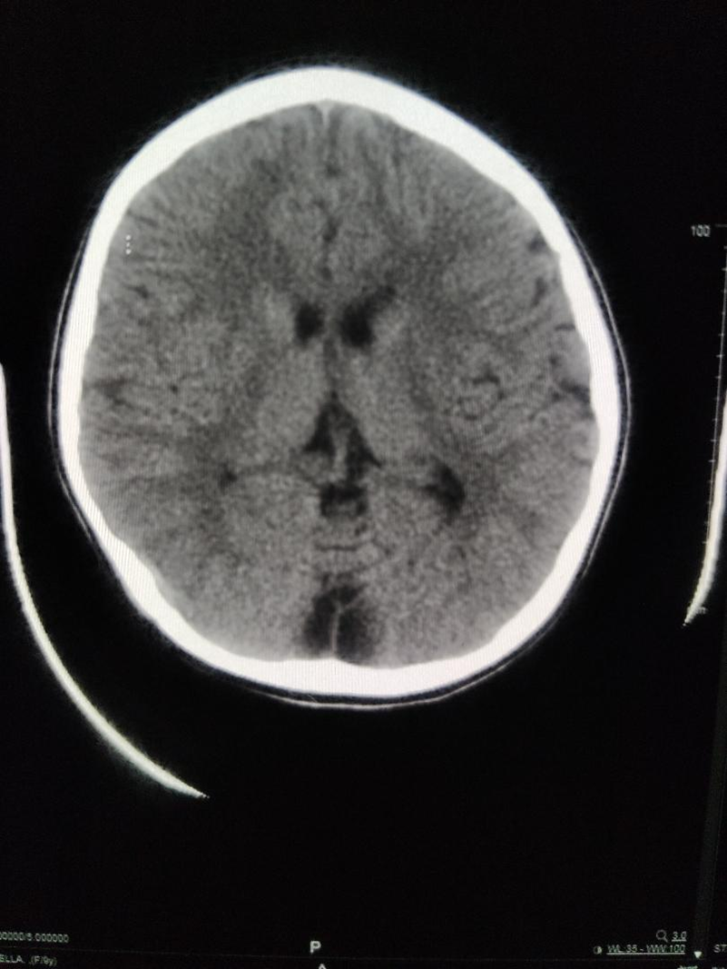

1)Describe the CT findings.

2)What is your differential diagnosis and list 3 points to differentiate the diagnosis

3)What are the factors to be considered when deciding the need for operation?

The CT film was interpreted by the attending EM physician as normal and discharged. Patient was found confusion the next day, GCS 12/15, BP: 190/60, HR: 50/min, Hstx: 5.6mmol/l. You reviewed the film and suspected there was raised intracranial pressure from the pathology. However, the CT room is currently occupied with another patient.

4)Name one bedside investigation you can do to confirm your diagnosis

5)Describe what abnormalities you expect to see.

Case 5

3/F,
c/o sudden onset of sob while running at the playground

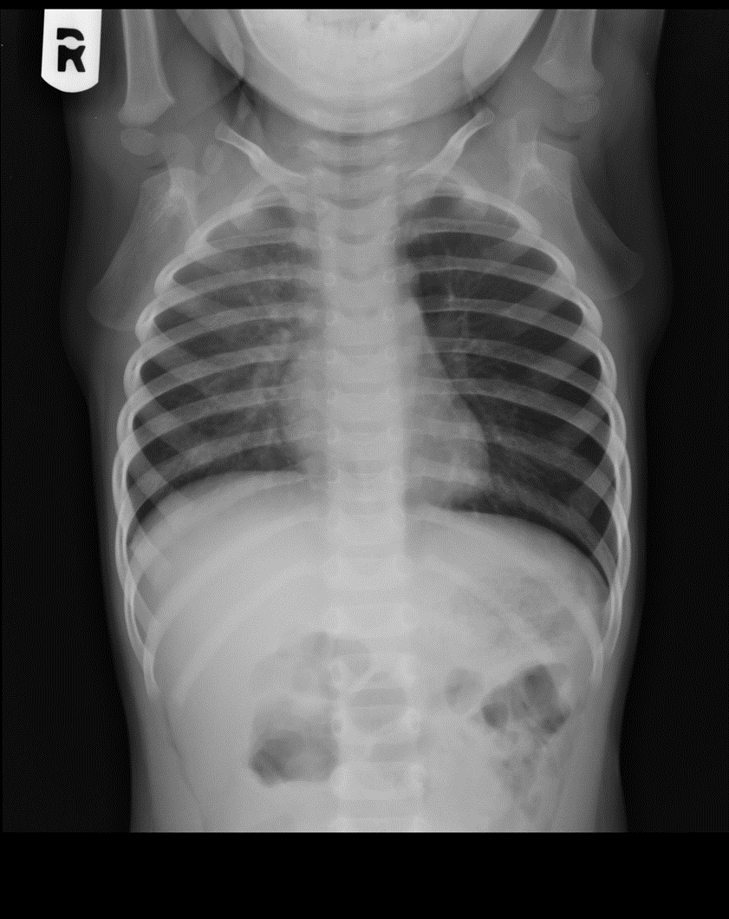

1)Please comment on the x-ray

2)How can you specify in your chest x-ray order form in order to better delineate the pathology?

3)Name two possible diagnoses

4)What further investigation will you do?

5)What are the possible complications?

